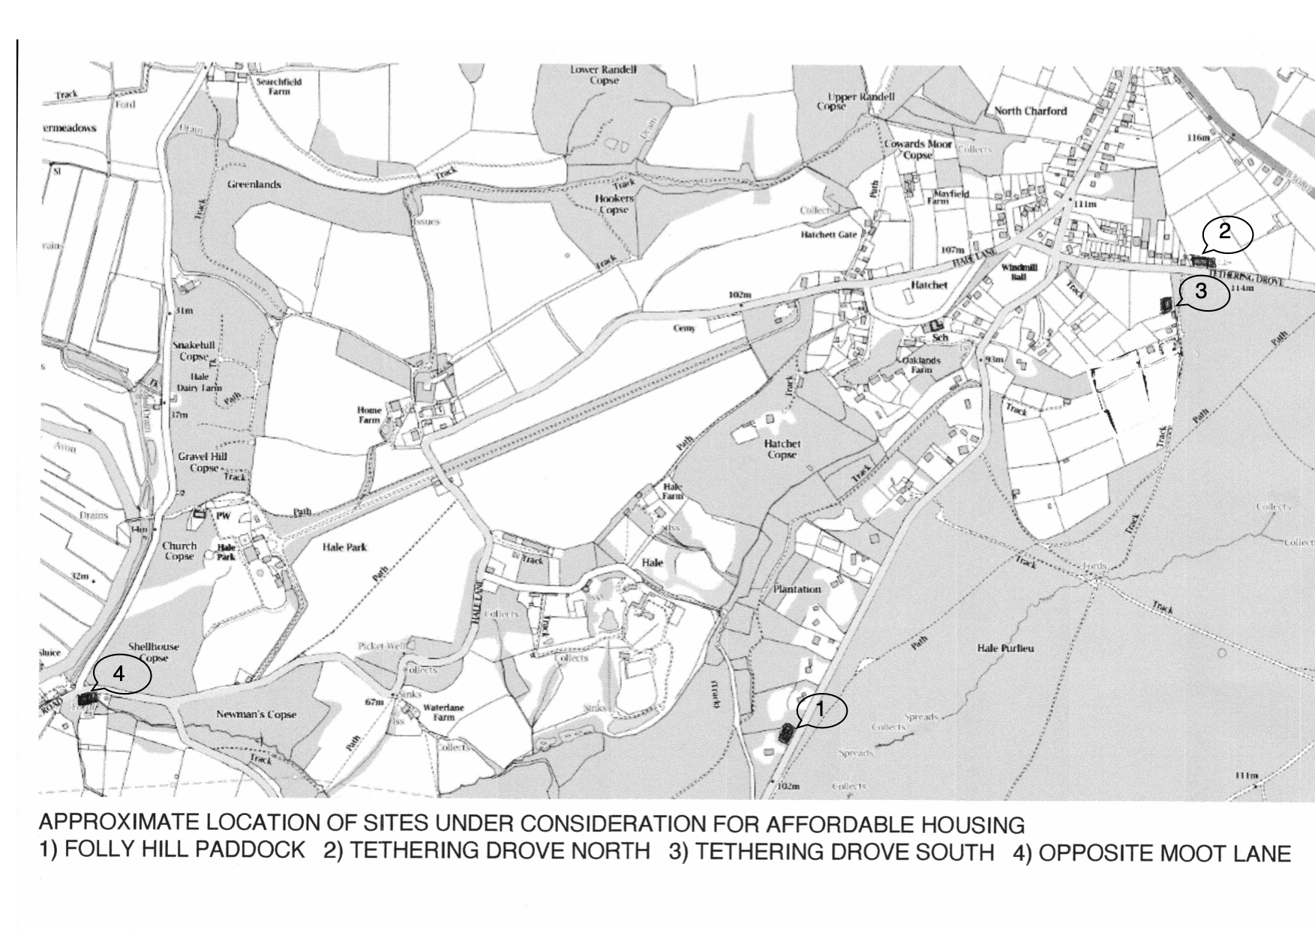
Approximate location of sites under consideration for Affordable Housing in Hale – July 2020.

